Key message: What is Blue Carbon?
A critical aspect of climate change mitigation and control of greenhouse gas emission going forward will be the restoration and preservation of ecosystems which act as natural carbon sinks. Coastal ecosystems such as tidal marshes, and seagrass beds can store carbon at rates equal to or exceeding those of terrestrial systems through their growth, especially below ground, and burial of organic matter. These coastal carbon stores have been termed “blue carbon”. Preliminary assessments of tidal marshes in the southern Kachemak Bay area indicated that these systems store much less carbon than initially assumed. However, based on the spatial extent and carbon storage capacities of the regions peat wetlands, better known as peatlands, these systems may prove to be important targets for carbon conservation projects. Since peatlands on the Kenai Peninsula exist close to the coast but are non-tidal, KBNERR staff refer to these peatlands as having “turquoise” carbon. (Figure showing peatlands of the Lower Kenai).
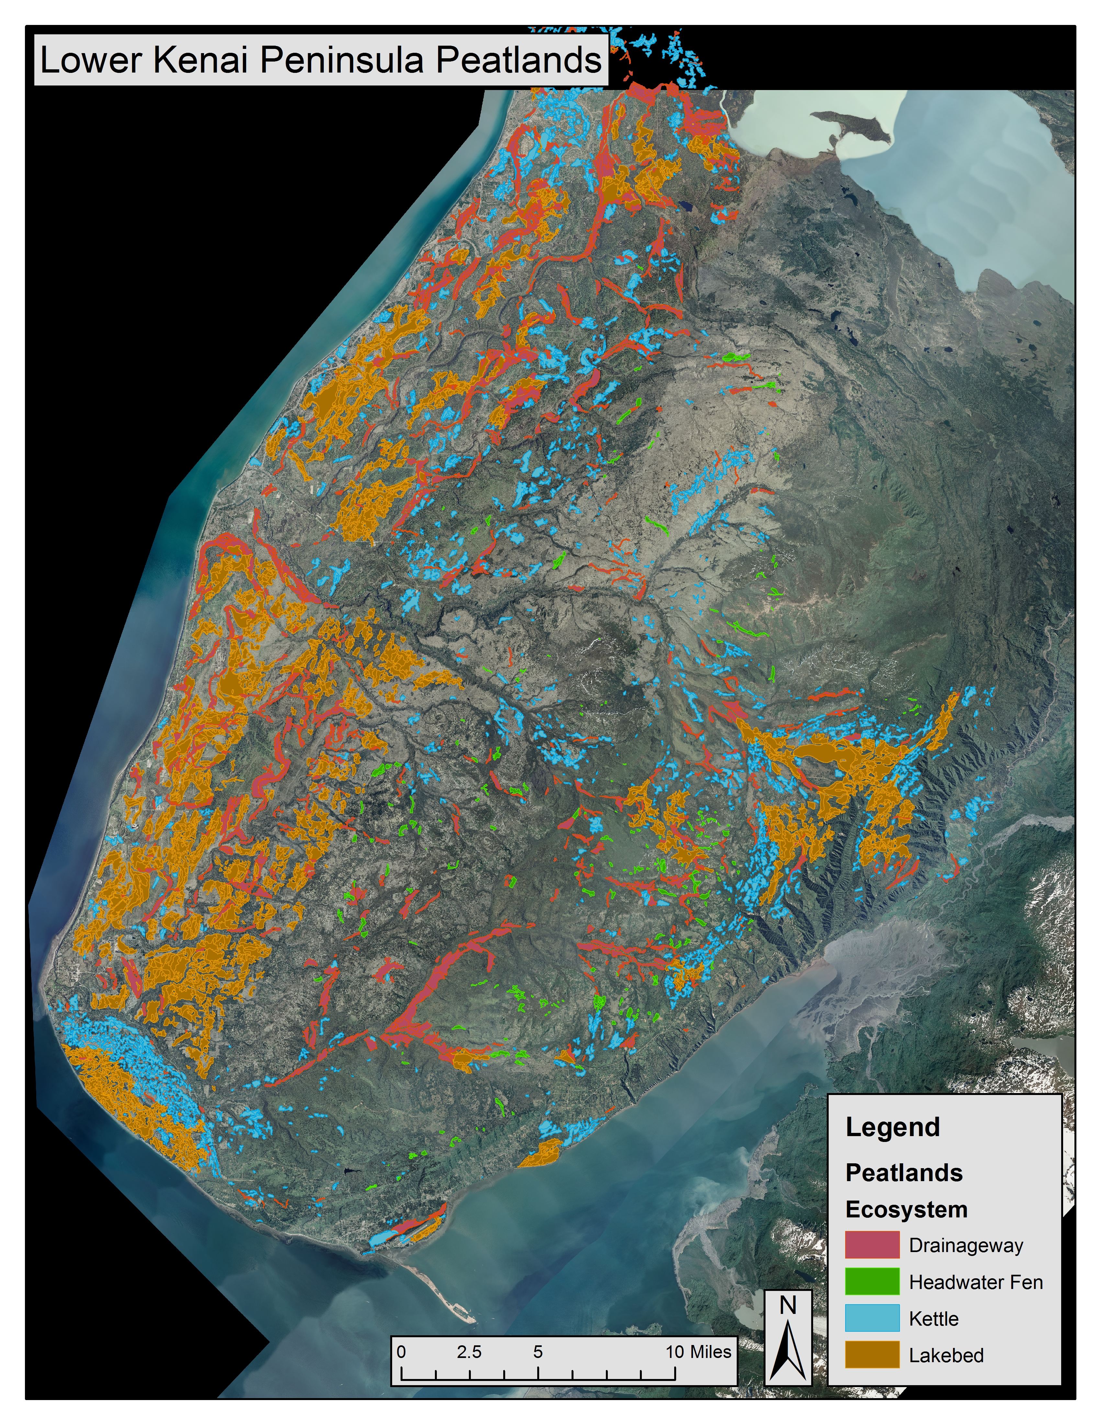

Key message: What is Carbon Finance and Conservation?
Conservation and/or restoration-based carbon finance projects are potentially powerful mechanisms to fund and incentivize continuation of these systems’ abilities to serve as greenhouse gas sinks. In theory, the profits generated by the implementation of a carbon offset project can equal or exceed more traditional and destructive development alternatives. Conservation of carbon-sequestering systems can therefore both mitigate climate change through the prevention of carbon-releasing activities, while also eliminating financial losses or opportunity costs incurred by typical development options. The ‘cap and trade’ carbon emission offset system is in place in some places around the world, including some US states. In the cap and trade system, regulators establish a “cap” on total greenhouse gas emissions that are allowed by a certain industry. That cap is then divided among businesses. The “trade” aspect refers to the markets, which are set up by regulators as places where entities that are over-emitting can buy allowances from companies which have under-emitted. Similar to an allowance, an offset is an emissions reduction which is made in one location to compensate for, or offset, emissions which are happening elsewhere. For example, this can allow polluting businesses in California to “reduce” their emissions by paying for emissions-reducing projects taking place elsewhere in the country. There are also voluntary carbon offset purchases in which companies (or individuals) choose to purchase carbon credits. Voluntary carbon credits are mostly used by companies looking to voluntarily offset their emissions to show social responsibility, establish a corporate image, and buy offsets in a speculative manner before emissions reduction is required by law. Both voluntary and regulated carbon offset programs are growing in demand.

Key message: How Could a Carbon Project Benefit Alaskan Communities?
In Alaska, estuarine wetlands cover only 8,400 km². By contrast, the state contains 132,196 km² of peatlands. So, by focusing on peatlands on the Kenai Peninsula initially, a peatland carbon project may also ultimately provide broad carbon financed conservation possibilities throughout the state.

The Kenai Lowland Salmon-Carbon Project Concept:
The Kenai Lowlands watersheds of the Kachemak Bay region 9,400 km², with nearly half of the landscape area characterized as peatlands. These peatlands contain large stores of carbon, which are currently sequestered and prevented from entering the atmosphere. The watersheds of the Kenai Lowlands also support abundant salmon that underpin robust commercial and sport salmon fisheries (valued at over $80 million per year on the Kenai Peninsula. In addition to the dependence on salmon as an economic mainstay, coastal communities on the Kenai Lowlands rely on salmon as an important local food source and cultural touchstone. While the majority of people in the Kenai Lowlands value and feel strongly about salmon, these feelings do not necessarily translate into salmon-friendly land-use strategies in landscapes consisting of a complex web of public and private land ownership. A complicating factor in any management strategy is that streams that provide salmon- habitats most often pass through watersheds (?) with multiple stakeholders. Thus maintaining the ‘natural capital’ of salmon-rich ecosystems will require synthesis of scientific research and science-informed land-use decisions made by all stakeholders.

Place-based research, led by the Kachemak Bay Research Reserve, along with partners from the Smithsonian, Baylor University and the University of South Florida, has led to a robust and compelling understanding of how landscape features contribute to salmon stream productivity. One very important element that has emerged are the regions vast peatlands. These peatlands cover close to half of the landscape surface, and vary in depth from 2-20 meters, with an average age of 18,000 years. This represents potentially large stores of carbon that could be released by the region’s rapidly increasing population and growing development pressures. Research has shown that the peatlands are also very important in supplying carbon that fuels stream food webs where juvenile salmon rear, and in moderating stream temperatures by acting as an insulating blanket. Water flowing through the peatlands maintains a relatively even temperature, keeping the region’s streams cool in the summer and relatively warm in the winter.
Unfortunately, these peatlands are often considered as wasted land, and there are very few legal protections to minimize impacts. They are sold inexpensively to unaware buyers, who then build access roads, driveways, and homes in the peatlands. In other scenarios, the peatland is mined to gain access to gravel deposits below, or potentially to harvest the peat for sale as a horticultural product. All of these activities disrupt the connections to, and support for, salmon streams that peatlands provide.
Because the Kenai Lowlands has a strong network of local representatives, community interest in salmon, and a very strong science base, .we believe that collaboratively developing a peatland carbon-salmon project will provide the foundation for carbon management and fisheries conservation through better land management, and that carbon financing can act as an incentive.

